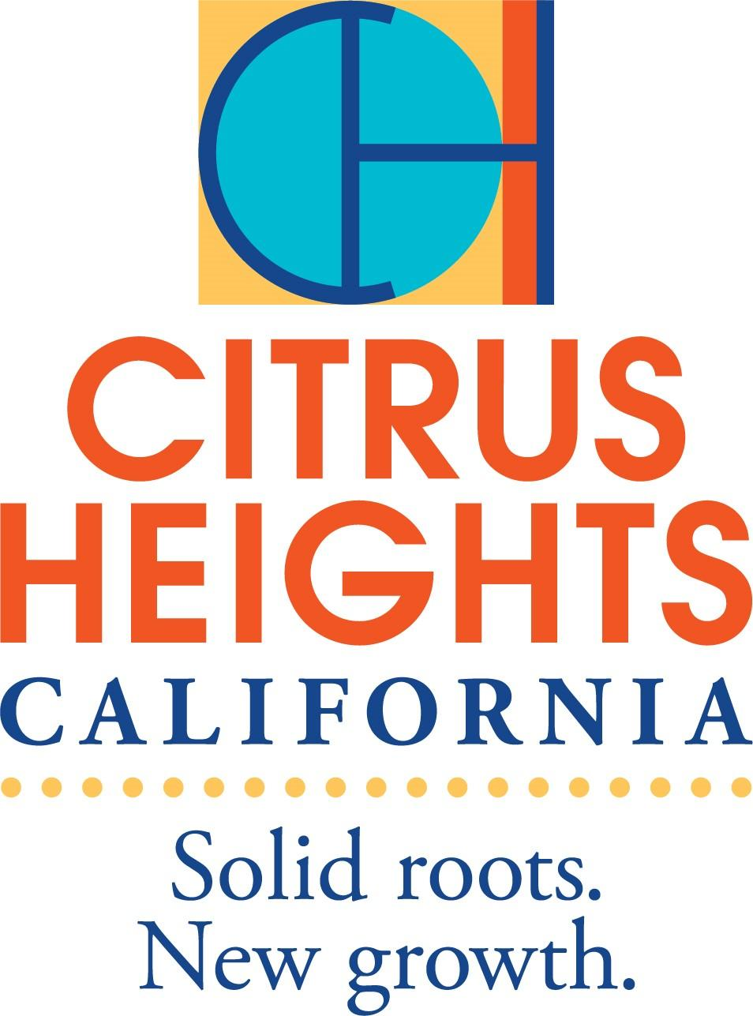

City of Citrus Heights

Mayor Tim Schaefer

Community Development Department

Casey Kempenaar, Community Development Director

Nicole Piva, Housing & Human Services Program Coordinator

NOTICE OF FUNDING OPPORTUNITY

July 7, 2023

2024 Annual Community Development Block Grant Funding:   
$90,000 Available for Public Services

The City of Citrus Heights is an "entitlement jurisdiction" under the federal Community Development Block Grant (CDBG) program. The city receives an annual award of CDBG funds from the U.S. Department of Housing and Urban Development (HUD). In 2023, the city was awarded $600,456 in CDBG entitlement funding. The uses of these funds are contained in the 2023 Annual Action Plan as adopted by the Citrus Heights City Council on October 27, 2022.

The eligible uses of CDBG funds offer a high level of flexibility in choosing program activities. Grantees are free to select those activities that best meet the needs of the community, in accordance with the national objectives and requirements of the CDBG program. Past programs that have received Citrus Heights CDBG funding include meals for seniors, youth programs, homeless services, housing crisis services, and domestic violence services.

This application is intended for non-profit service provision. More detailed information on these uses may be found in the Strategic Plan section of the [Consolidated Plan](http://ca-citrusheights.civicplus.com/DocumentCenter/View/15178/Final-Version-2020-24-Con-Plan-and-2020-Annual-Action-Plan?bidId=), available on the city’s webpage.

Agencies whose proposals are selected and who are awarded funds will be sub-recipients of the federal award. These agencies will be required to execute contracts with the city that include required federal contracting language. Contracting agencies will be required to be familiar with and to comply with all CDBG program regulations and all other applicable federal administrative requirements; to submit regular reports regarding progress, expenditures, and clients served; and to provide evidence of adequate insurance. Per federal regulations, and as a condition of funding, agencies must collect and report information regarding the age, income, race, ethnicity, and household composition of those served.

Proposals must include the information and documentation as described in the Proposal Requirements. Proposal packets will be available **Friday, July 7, 2023**. Funding for proposals submitted under this Notice of Funding Opportunity is scheduled to be considered by the Citrus Heights City Council on **Thursday, October 12, 2023** and the Citrus Heights City Council will approve funding allocations on **Thursday, October 26, 2023**. Agencies will be notified of their selection after the October 26 City Council meeting via email. Depending upon Congressional appropriations, typically released mid-May the city’s actual allocation for 2024 CDBG entitlement funds may be increased or decreased and agencies will be notified by email of any increase or decrease.

|  |  |
| --- | --- |
| **APPLICATION SUBMITTAL PROCESS** | |
| One (1) electronic copy. The electronic copy must be submitted as a PDF file. Submit your application via email to Nicole Piva on **Monday, August 7, 2023 by 4:00 PM**. *The date and time the email is delivered will be confirmation the application was received on time.* | |
|  | |

For more information or to receive a proposal packet you may visit the city’s [Community Development Block Grant](http://ca-citrusheights.civicplus.com/380/Community-Development-Block-Grant) webpage or send an email to Nicole Piva at [npiva@citrusheights.net](mailto:npiva@citrusheights.net). TTY/TDD users with questions or comments may call the California Relay Service by dialing 7-1-1. In addition, you may contact the ADA Coordinator at (916) 725-2448.

**CDBG PROGRAM GENERAL INFORMATION**

Community Development Block Grant (CDBG) programsallocate funds from the U.S. Department of Housing and Urban Development (HUD) to state and local governments, who may then allocate them to private non-profit community development corporations, community-based organizations, city departments, and private for-profit corporations, for qualified activities that benefit low- and moderate-income areas or low- and moderate-income persons. Low- and moderate-income households are currently defined as those having gross annual incomes at or below 80 percent of the area median income, adjusted for household size. The 2023 income limits released by HUD state the maximum income for a household of four is $85,750.

**PLEASE NOTE**

**THIS APPLICATION IS ONLY FOR PUBLIC SERVICE FUNDING**

The City of Citrus Heights has a competitive process only for the public services portion of CDBG funding.

**ELIGIBLE ACTIVITIES**

Applicants should first determine whether or not their proposed activity is eligible under the CDBG regulations at 24 CFR570.201. All projects must primarily benefit low- and moderate-income persons. If the activity was not funded by CDBG last year, please contact Nicole Piva at [npiva@citrusheights.net](mailto:npiva@citrusheights.net) to determine if the activity is eligible.

Activities that are generally eligible for CDBG funding include the following, but not limited to employment assistance, crime prevention, substance abuse, youth services, domestic violence, senior services, and fair housing counseling services. Applicants with public service projects must submit the attached application.

Refer to the Application Checklist early in the process. Many of the required documents may take time to pull together. You will need approval of the application from your Governing Board.

The city offers a CDBG Funding Assistance Workshop should the applicant wish to hear more about the city’s CDBG program. Attendance at the workshop is optional. The workshop will be held **Wednesday, July 19, 2023** from 1:00 PM to 2:00 PM via Zoom. For information on how to join the workshop send an email to [npiva@citrusheights.net](mailto:npiva@citrusheights.net) with your contact information.

**APPLICATION REVIEW**

Once the final application date and time has passed, applications may not be amended or substituted, unless the amendment has been requested or permitted by the city staff. City staff reserves the right to contact an applicant if additional information is required. City staff is available to provide technical assistance prior to the application due date.

City staff will review applications to determine whether the proposed activities meet the minimum eligibility criteria. Proposed activities will be evaluated based on their benefit to low- and moderate-income households, project readiness, and feasibility for successful and timely implementation. City staff may conduct interviews with qualifying applicants and provide the applicant the opportunity to clarify their application and advise city staff of any additional factors that may be relevant.

**APPLICATION TIPS AND INSTRUCTIONS:**

* The attendance of the workshop is helpful in determining if the proposed project is an eligible CDBG activity. The workshop is optional.
* Staff is available until the application deadline to answer questions about the application requirements or process.
* Review the Application Checklist early in the process. Many of the documents may take time to pull together. You also need approval of the application from your governing board.
* Submit
  + One (1) electronic copy. The electronic copy must be submitted as a PDF. Electronic copies must be submitted via email to Nicole Piva via email.
  + Keep a copy of your submittal as a reference.
* Applications must be received by email by **Friday, August 7, 2023 by 4:00 PM.** Applications emailed after 4:00 PM will not be considered.
* The application must be completed and submitted in its entirety. Check carefully to ensure that you have answered all applicable questions. Do not delete questions that do not apply to your organization’s project.
* Application information can be submitted on attachments to the original application. The application should be noted *See Attachment No.* for easy reference.
* Attachments must be numbered or lettered and must reference the corresponding section and question number from the application.

#### TIMEFRAME

#### The city anticipates the following schedule for reviewing submitted applications and determining funding awards.

|  |  |
| --- | --- |
| July 7, 2023 | Release Notice of Funding Opportunity  2024 Community Development Block Grant Funds |
| July 19, 2023 | 2024 Application Funding Workshop  1:00 PM to 2:00 PM  For information on how to join the workshop send an email to  [npiva@citrusheights.net](mailto:npiva@citrusheights.net).  *Workshop is Optional* |
| August 7, 2023 | Applications are Due  4:00 PM  Email Applications to [npiva@citrusheigths.net](mailto:npiva@citrusheigths.net) |
| October 12, 2023 | City Council Meeting  6:00 PM  Draft 2024 Annual Action Plan considered, preliminary allocation  of funds. |
| September 27 - October 26, 2023 | Annual Action Plan Public Comment Period |
| October 26, 2023 | City Council Meeting  6:00 PM  Final 2024 Annual Action Plan considered, final allocation of funds. |
| January 1, 2024 | Program Year Begins  (January 1 – December 31, 2024) |

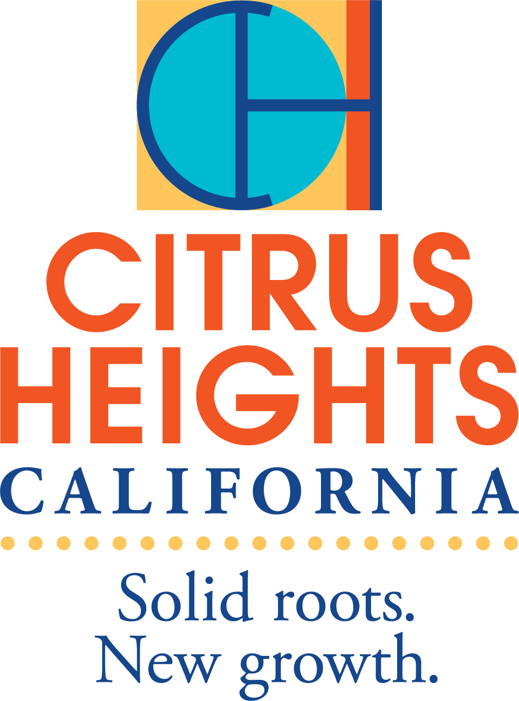

City of Citrus Heights

6360 Fountain Square Drive, Citrus Heights, CA 95621

Community Development Department

**Application for 2024 Community Development Block Grant Funding**

|  |  |  |
| --- | --- | --- |
| **Organization Information** | | |
| Organization Legal Name: | | UEI #: |
| Address: | | |
| City: | State: | Zip Code: |
| CEO/Executive Director Name: | | Title: |
| Phone No.: | Email: | |
| **Project/Program Information** | | |
| Program Name: | | |
| Location where activities will take place: | Address: | City: |
| Program Manager Name*: | | Title: |
| Phone No.: | Email: | |
| *\*The person identified here should be the person who is paid by CDBG and will report on the client demographics and goals.* | | |
| Finance Manager Name**: | | Title: |
| Phone No.: | Email: | |
| *\*\*The person identified here should be the person who ensures that the financial information is correct.* | | |

**Amount requested: $ Total program costs: $**

**SECTION 1. COMMUNITY NEED & BENEFIT**

**(Scoring Criteria – Maximum 10 points)**

1. **What community needs and gaps in service does this project/program address?** (Identify the current need in the community for the proposed project in the context of the CDBG priorities. Describe any gaps in service and the need for the services proposed. Provide current local statistics, agency statistics or other evidence to document the needs and gaps.)
2. **Will the project provide a new service based on the 2020-2024 Consolidated Plan?** (If yes, describe. If no and is continuing service, answer the next question)
3. **If the project is a continuing service, (funded in the 2020-2024 Consolidated Plan) answer the following questions:** 
   1. **What is your current level of services?** (Describe, what the service is: who and how many do you serve now; how often is the service provided; number of staff)
   2. **Does CDBG fund this program currently?** If yes, how much funding do you receive?)
   3. **In quantifiable terms, how will new or increased funding be used to provide a quantifiable increase in the current level of service?**
   4. **Does it align with the goals and strategies in the 2020-2024 Consolidated Plan?**
4. **Describe the population who will benefit from the service.** (homeless or at risk of being homeless, children, youth, victims of domestic violence, special needs, etc.)
5. **What is the proximity of your location to the persons being served?**
6. **How will the program/project collaborate with other service providers that service the same population?** (Include any formal agreements or describe a history of partnerships in the community.)
7. **Program Eligibility – National objective (choose one).**

Low/Mod Limited Clientele (LMC) 570.208 (a) (2) – at least 51% of program participants must be low/mod (80% of AMI or below-current income limits). Collect household date on income, family size, and race & ethnicity information to substantiate that person being assisted is low and moderate income.

Low/Mod Limited Clientele Presumed Benefit 570.208 (a)(2)(A) – An activity can be considered Presumed Benefit if the program benefits abused children/spouses, elderly, severely disabled adults, homeless, illiterate, persons with AIDS, or migrant farm workers. Collect race & ethnicity information.

Low/Mod Limited Clientele Nature or Location Benefit 570.208 (a)(2)(D) An activity can be considered eligible under this category if the activities are of such a nature and in such a location to conclude low/mod clientele serviced (i.e.: funding a daycare in a Public Housing Complex – the location of the activity implies eligibility). Collect race & ethnicity information.

Low/Mod Area Benefit (LMA) 570.208 (a) (1) – An activity can be considered LMA if the service area, meaning the radius of where you will be drawing program participants from, is predominantly low/mod (attach map of service area). Activity must provide services to ALL residents.

**SECTION 2. PROJECT DESCRIPTION & APPROACH**

**(Scoring Criteria – Maximum 10 points)**

1. **Provide a clear, detailed description of the program.**
2. **Define and describe the services that will be provided by this program including your organization’s experience in serving the target population.**
3. **When is the program offered? (list hours of program operation for each day)**

|  |  |  |  |  |  |  |  |
| --- | --- | --- | --- | --- | --- | --- | --- |
|  | Monday | Tuesday | Wednesday | Thursday | Friday | Saturday | Sunday |
| Time/Duration: |  |  |  |  |  |  |  |

1. **Describe the staffing plan and qualifications (such as, education, training, or experience) of the staff members who will manage the project and provide the services.**
2. **Indicate the number of unduplicated persons to be assisted and the number to be assisted with CDBG funds.** *In order to be considered to receive funding at least 51 percent of the beneficiaries must be low- or moderate-income persons or households.*

|  |  |
| --- | --- |
| **# Served** | **Persons** |
| Total assisted with **all funds** |  |
| Total assisted with **CDBG funds** |  |

1. **HUD Performance measures:**

**A. Select one of the three objectives that best describe the purpose of the public service activity.**

______ Provide essential public service to improve quality of life for individuals and families with low-moderate incomes, including special needs populations and those experiencing homelessness or at risk of becoming homeless.

______ Increase, maintain, and improve the supply of safe, decent, and affordable housing

______ Create economic opportunities for individuals and families with low-moderate incomes.

1. **Select one of three outcome categories that best describe what the public service activity will achieve.**

______ Availability/Accessibility

______ Affordability

______ Sustainability

1. **Select one of the following indicators.**

______ Number of persons receiving new or continues access to the service or benefit; or

______ Number of persons receiving improved access to the service or benefit

1. **Describe how your organization will track, count and report this data.**

**SECTION 3. ORGANIZATIONAL CAPACITY**

**(Scoring Criteria – Maximum 6 points)**

1. **Describe any specific experience your organization has in administering public funds.**
2. **Describe your organization’s financial management including financial reporting, record keeping and accounting systems.**
3. **If you received CDBG before, did you meet the reporting requirements?**
4. **Projects that receive a CDBG funding award are sometimes awarded less than the amount originally requested. Please indicate here whether your proposed activity could be undertaken with less funding and how that would affect the project scope.**
5. **Demonstrate that the proposed activity is economically feasible and can be implemented timely and cost-efficient manner within the proposed program year.**

**SECTION 4. FINANCIAL FEASIBILITY**

**(Scoring Criteria – Maximum 4 points)**

The city encourages CDBG funds to be used primarily as gap funding. Identify sources of leveraged funding for this activity. Attach copies of funding commitment letters or other evidence of funding support to the application.

1. **Project Budget (Maximum 2 points)**

|  |  |
| --- | --- |
| **Funding Sources** | **Amount** |
| CDBG funds requested in this application |  |
| Prior year CDBG funds received |  |
| Citrus Heights Community Support funds currently receiving |  |
| Other Federal funds received (if any) |  |
| Private funds received (if any) |  |
| **Public service group, below show how CDBG funds will be used for the program year (January-December)** | |
| Salaries *(funding of actual salaries, fringe benefits will not be paid)* |  |
| Supplies |  |
| Program Administrative Costs |  |
| **TOTAL CDBG BUDGET** | **$** |

**STAFF/SALARY BREAKDOWN**

Please show all staff positions related to the proposed activity regardless of funding source. If multiple staff members have the same position/title, list them separately (for example, Counselor 1/Counselor 2). You must submit job descriptions with your application for each position title identified below.

|  |  |  |  |  |  |  |  |  |  |  |  |  |
| --- | --- | --- | --- | --- | --- | --- | --- | --- | --- | --- | --- | --- |
| **Position Title** | **Is this a current or proposed position?** | **Annual Salary** | **Total Annual Salary** | | ***x*** | **% Time Spent on this CDBG Project/Program** | | | ***=*** | **Total Position Cost Requested from CDBG** | | |
| *Example: Case manager* | *Current* | *$25,000* | *$5,000* | *$30,000* | | | *x* | *40%* | | | ***=*** | *$12,000* | |
|  |  |  |  |  | | | *x* |  | | | ***=*** |  | |
|  |  |  |  |  | | | *x* |  | | | ***=*** |  | |
|  |  |  |  |  | | | *x* |  | | | ***=*** |  | |
|  |  |  |  |  | | | *x* |  | | | ***=*** |  | |

1. **What funds have you committed from your organization or have obtained from another organization to fund the project/program described in this application? (Leveraged funds are defined as “a financial commitment towards the costs of a project or program other than the granting agency”. (Maximum 1 point)**
2. **What steps has your organization taken to sustain its mission as defined below? (Sustainability is defined as the ability of an organization to continue its mission or program into the future. A project/program can be considered sustainable in three main categories: organizational, financial, and community sustainability.) (Maximum of 1 point)**

**APPLICATION CHECKLIST**

In order for your application to be accepted, in addition to the application itself, your organization must meet and submit the following threshold items:

* Is the proposed activity eligible?
* Demonstrate your administrative capacity and experience?
* Complete all budget sheets and attach required financial documentation?
* Include all requested attachments/certifications?
* Articles of Incorporation
* Completed W-9
* IRS 501(c)(3) Designation Letter (pending letters will not be accepted)
* Current list of Board of Directors
* Organizational Chart
* Resumes of Chief Administrative and Chief Fiscal Officers
* Certified Organization Audit/Financial Statements of most recent year
  + - Financial statements audited by a CPA or Profit and Loss Statement and General Ledger printout
* Project Budget (for the proposed activity)
* Current fiscal year agency budget, including all funding sources
* Signature Authorization form
* Disclosure of Lobbying Activities (standard Form LLL – Rev 7-99)
* Byrd Amendment Certification for Contracts, Grants, Loans and Cooperative Agreements

**CERTIFICATION**

To the best of my knowledge, all materials submitted as part of this application packet is true, correct and the governing body of the applicant organization has duly authorized said documents and this request for funding.

Authorized Signature: ________________________________Date: _______________________

Print Name: ____________________________________________________________________

Title: _________________________________________________________________________

**SIGNATURE AUTHORIZATION FORM**

The Board of Directors of ____________________________________ does hereby resolve that on the date of ________________________, the Board reviewed the Application for Community Development Block Grant funds to be submitted to the City of Citrus Heights Community Development Block Grant Program for funding consideration for the **Calendar Year 2024** and in a proper motion and vote to approve this application for submission.

The Board further certifies that the organization making this application has complied with all applicable laws and regulations pertaining to the application and is a non-profit organization, tax-exempt, and incorporated in the State of California.

________________________________ *(name of organization)* hereby proposes to provide the services or project identified in the Scope of Services in accordance with this application for Community Development Block Grant Funds. If this application is approved and this organization receives CDBG funding from the City of Citrus Heights, this organization agrees to adhere to all relevant federal, state, and local regulations and other assurances as required by the city. As the duly authorized representative of the organization, I certify that the organization is fully capable of fulfilling its obligation under this application as stated herein.

I further certify that this application and the information contained herein are true, correct, and complete.

**I also authorize the following person(s) to have signatory authority regarding this grant**:

|  |  |  |
| --- | --- | --- |
|  |  |  |
| Name |  | Title |

|  |  |  |
| --- | --- | --- |
|  |  |  |
| Name |  | Title |

______________________________________________________________

President/Board of Directors (or other authorized person)

_______________________________________________________________

Date

**PENALTY FOR FALSE OR FRAUDULENT STATEMENT**

U.S. Code Title 18, Section 1001, provides that a fine of up to $10,000 or imprisonment for a period not to exceed five years, or both, shall be the penalty for willful misrepresentation and the making of false, fictitious statements, knowing same to be false.

